**UPEI SCHOOL OF MATHEMATICAL AND COMPUTATIONAL SCIENCES**

**CS2710 FINAL PROJECT – ARDUINO WHEATHER STATION**

**BY**

**Samuel Nnam (135228) and Nathan Munn (144212)**

**December 16th, 2017**

**TABLE OF CONTENTS**

**1.0 Introduction**

**2.0 Components**

**3.0 Components Functionality**

**4.0 Connection Process / Building**

**5.0 Code**

**6.0 Testing Process / Running the experiment**

**6.1 Collection / analyzing Data**

**6.2 Graphing Data**

**7.0 Conclusion**

**8.0 References**

1. **Introduction**

The following statement is an introduction to highlight the problem that team has been faced with, as well as an introduction to the end goals the team has set to accomplish. The team’s client, Professor Chris Vessey a computer science instructor at the University of Prince Edward Island. The team came with an idea of creating a platform called Arduino Weather Station using Arduino system which will help the individuals living in Charlottetown, Prince Edward Island to stay safe during winter through reading the temperature and humidity updating the weather condition through social media (twitter). The major idea was based on getting two Arduino UNO’s using Wi-Fi shield at different locations to collect data using Temperature and Humidity sensor and send the collected data to an Arduino Mega which uses the Ethernet shield to collect and save the data to an SD card then the collected data will be sent out through a social media server (twitter) using a twitter token code. A twitter account was created as a communication means where the collected data is sent out to the society for a weather condition update.

The team was able to carry out the above tax through setting up two Arduino UNO’s using a Wi-Fi shield, Temperature and Humidity sensor and CdS light sensor at a different internet location (that is, **not** on the same network-two different locations). The two Arduino UNO’s was used as a client which we called **Node.** The node functionality was based on data collection and sending out the collected data to a second system which stores the collected data.

The second system was referred to as the server with a setup using the Arduino Mega which consist of the Ethernet shield, RTC, LCD Display, an Mp3 player as part of the connections. The server functionality was based on getting the data from the **Node** and storing the data and sending out the stored data to the social media server every 5 minutes; that is, Using the twitter account to send out the current temperature, average current temperature, current humidity and average humidity at a given location.

**2.0 Problem Statement**

The society needs a weather station updater that automatically update the weather situation every 5 minutes which will save the people time from watching television but rather use social media to get update about current weather condition since social media is common in the society and also the weather station will help the people to stay safe during the winter season.

**3.0 Components**

The materials that are required for this project includes:

* 2 X Arduino UNO
* 1 X Arduino Mega
* 1 X Ethernet/SD Shield
* 2 X ESP8266 Wi-Fi Shield
* 1 X Real-Time Clock module (RTC)
* 2 X microSD card
* 2 X LCD Display (module 16x2)
* 1 X LCD Display (module 20x2)
* 1 X IR Remote
* 2 X Cds photocell
* 1 X Mp3 player
* 2 X DHT-11 Sensor
* 2 X LM35DX Sensor
* 1 X Breadboard

1. **Components Functionality**

The functionality for the components are:

* **Arduino UNO** is a microcontroller board which consist of 14 digital input/output pins (of which 6 can be used as PWM outputs), 6 analog inputs, a 16 MHZ quartz crystal, a USB connection, a power jack, an ICSP header and a reset button. It also contains everything needed to support the microcontroller [1].
* **Arduino Mega** is a microcontroller board which consist of 54 digital pins (of which 15 can be used as PWM outputs), 16 analog inputs, 4 UARTs (hardware serial ports), a 16 MHZ crystal oscillator, a USB connection, a power jack, an ICSP header, and a reset button. It also contains everything needed to support the microcontroller [1].
* **The Arduino Ethernet** Shield R3 (assembled) allows an Arduino board to connect to the internet. It consists of micro SD card connector and supports up to four simultaneous socket connections. The ethernet shield connects to an Arduino board using long wire-wrap headers which extend through the shield. This keeps the pin layout intact and allows another shield to be stacked on top. Arduino uses digital pins 10, 11, 12, and 13 (SPI) to communicate with the W5100 on the ethernet shield. These pins cannot be used for general i/o [2].
* **ESP8266 Wi-Fi Shield** module is industrial-grade chips ESP8266, which is ESP-12E with metal shield with strong anti-interference ability. The shield is pin-compatible with Arduino UNO, Mega2560 and other control board. A voltage converter chip is used to deal with 3.3V (ESP8266) and 5V (Arduino); Dual DIP switches is used for serial ports so that this module shield can be used alone as an Arduino UNO expansion board, also be used as esp8266 expansion board; Serial data is transported to Wi-Fi device transparently [3].
* **Real-Time Clock module (RTC)** is a simple breakout board for the DS1307 real-time clock which accurately keep track of seconds, minutes, hours, days, months, and years for almost a decade.
* **MicroSD card** helps to store the collected date for proper analyzation.
* **LCD Display** is a flat-panel display that uses the light modulating properties of liquid crystals. Light crystals do not emit light directly, instead using a backlight or reflector to produce images in colors [4].
* **IR Remote** Infrared remote is used to wirelessly control
* **Cds photocell**
* **Mp3 player**
* **DHT-11 Sensor**
* **Breadboard** helps with the connection of all the components.

1. **Connection process / Building For Node A and Node B**

The connection process was one of the major steps that was carried out during this project and this was done by connecting all the components with a current supply of 5V from the Arduino UNO and Connecting the Ground (GND) pin from the Arduino UNO. The connection for both

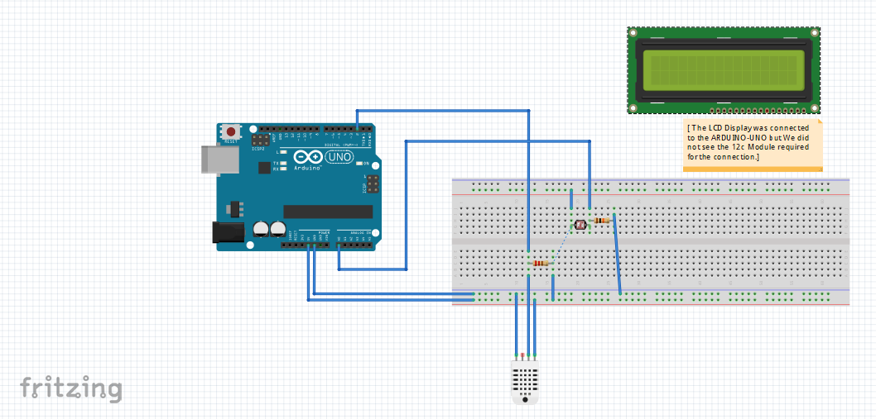

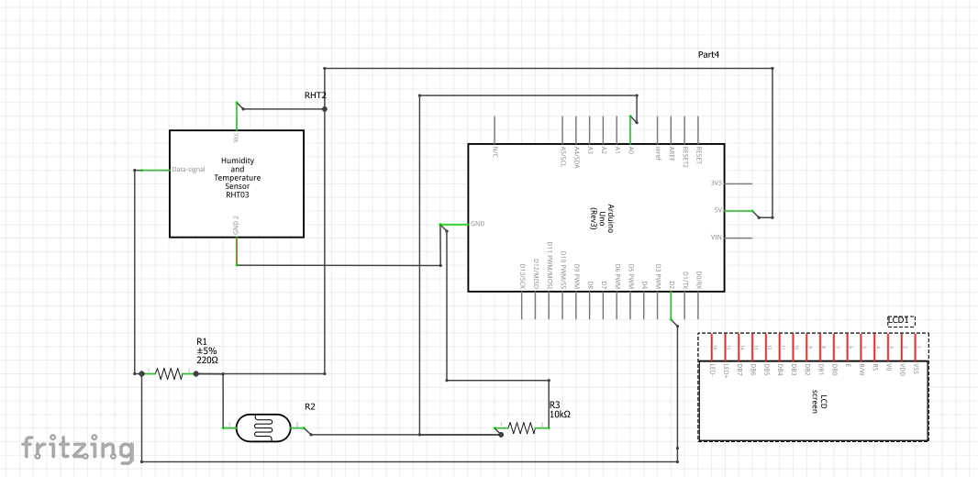

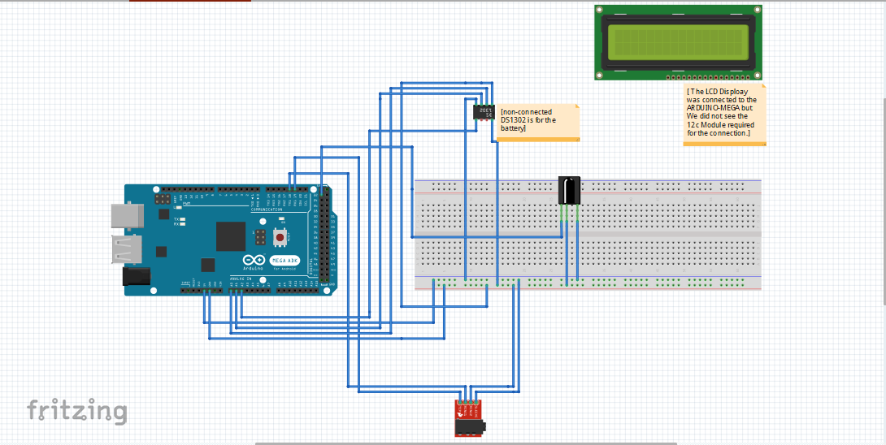

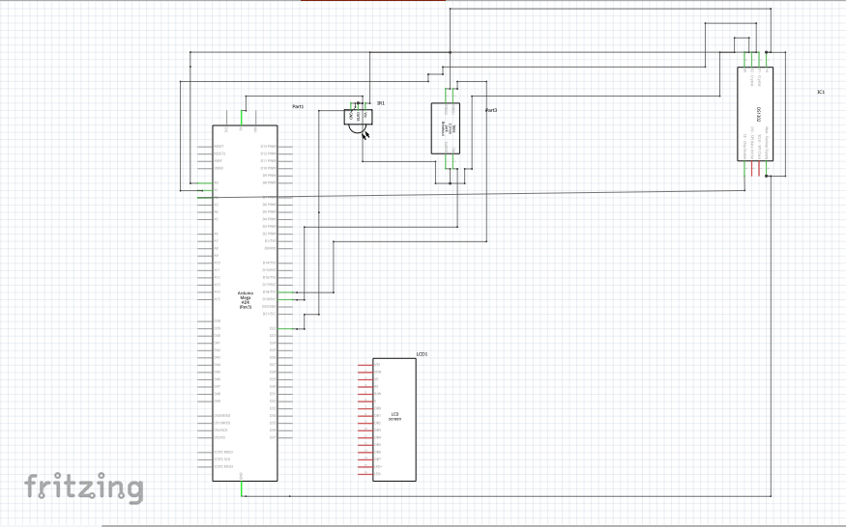

**Reference**

**[3]”Tindie”** https://www.tindie.com/products/doit/arduino-uno-r3--esp8266-wireless-wifi-shield/

**[4]”Arduino**” <https://en.wikipedia.org/wiki/Liquid-crystal_display>

**[5]**

[6]

[7]

[8]